Assessment 1

1. Click to Devops in aws v2
2. Start instance
3. Open the terminal of machine

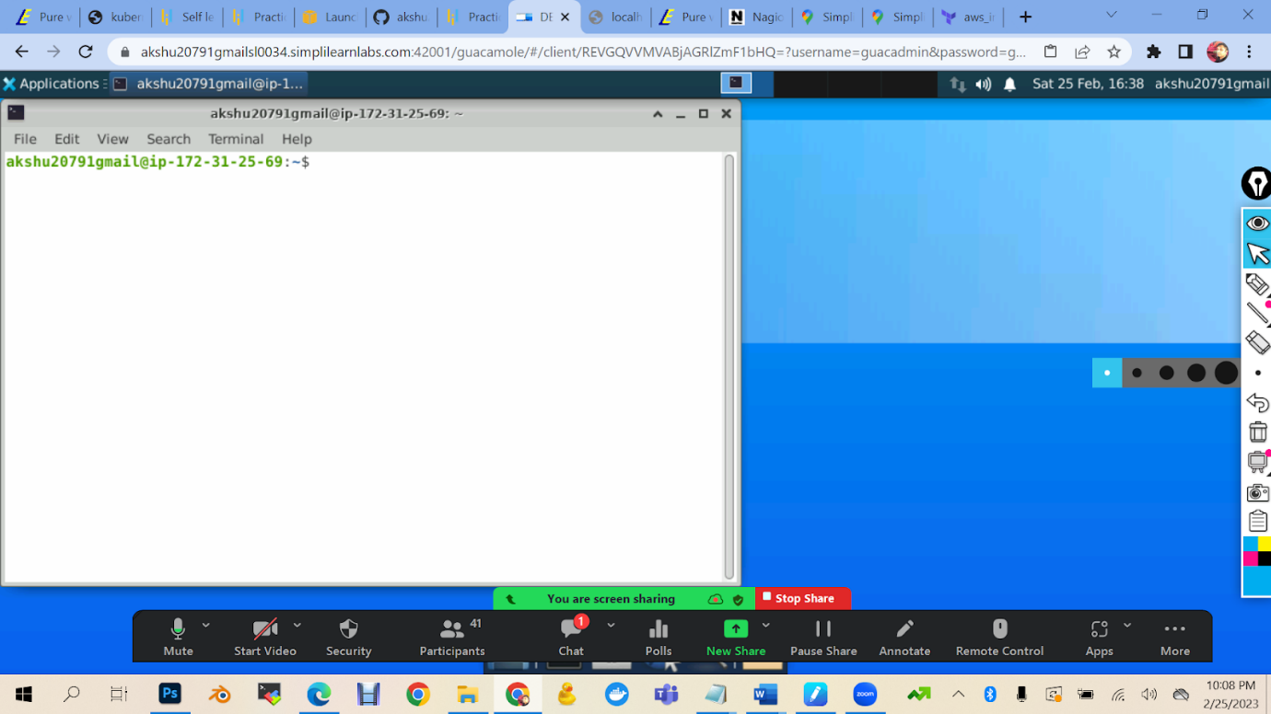

1. Checking is aws cli is installed in machine or not

aws –version

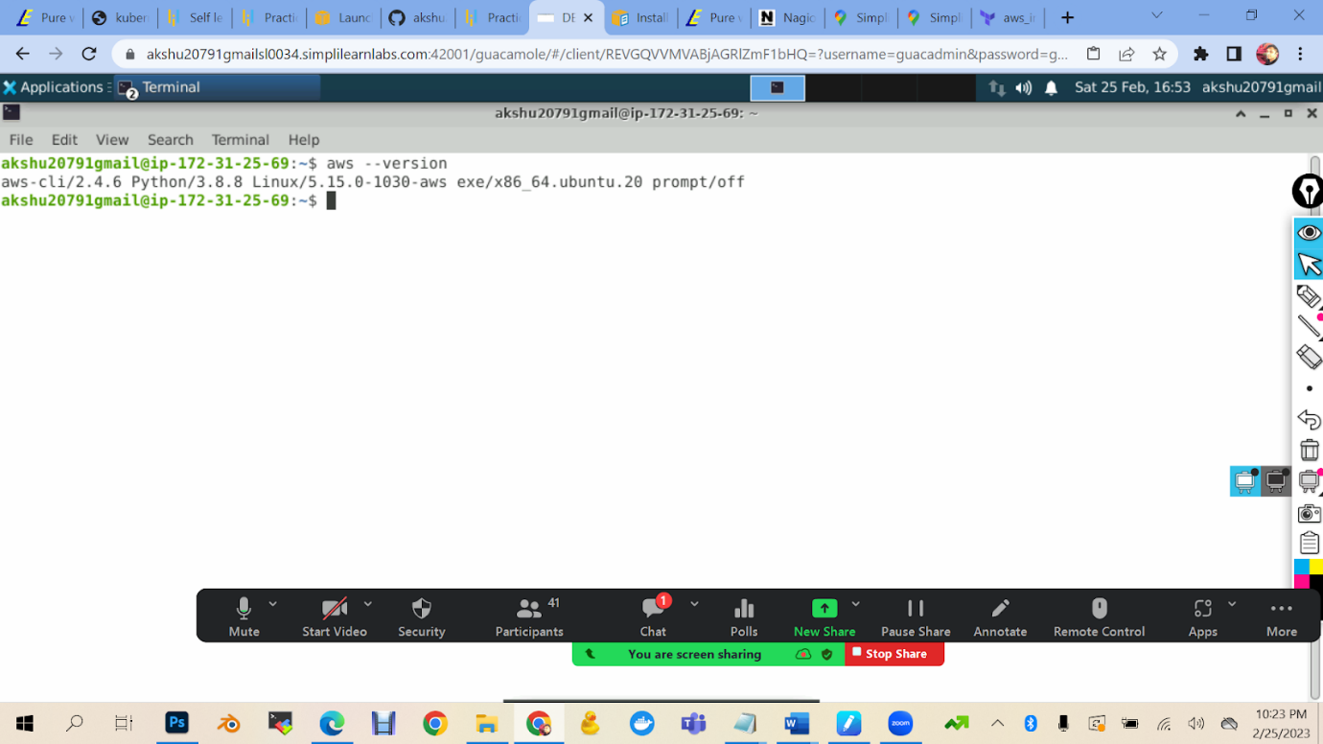

1. Terraform --version

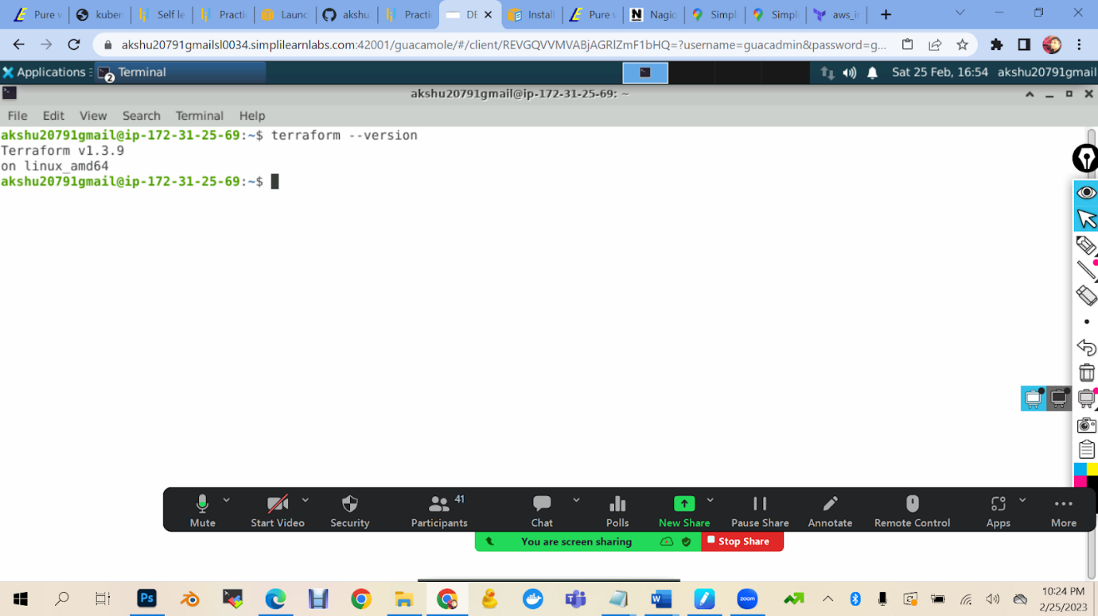

Since the terraform is not updated we will first update the terraform

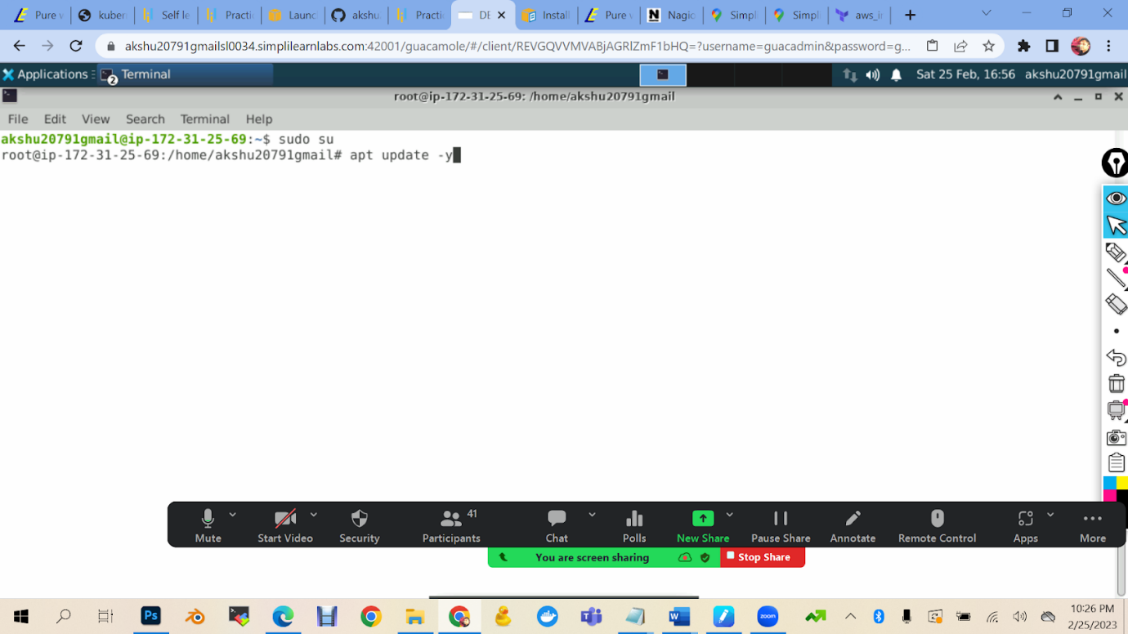

sudo su

apt update -y

1. Go to the link <https://developer.hashicorp.com/terraform/downloads>

wget -O- https://apt.releases.hashicorp.com/gpg | gpg --dearmor | sudo tee /usr/share/keyrings/hashicorp-archive-keyring.gpg

echo "deb [signed-by=/usr/share/keyrings/hashicorp-archive-keyring.gpg] https://apt.releases.hashicorp.com $(lsb_release -cs) main" | sudo tee /etc/apt/sources.list.d/hashicorp.list

sudo apt update && sudo apt install terraform

1. terraform –version

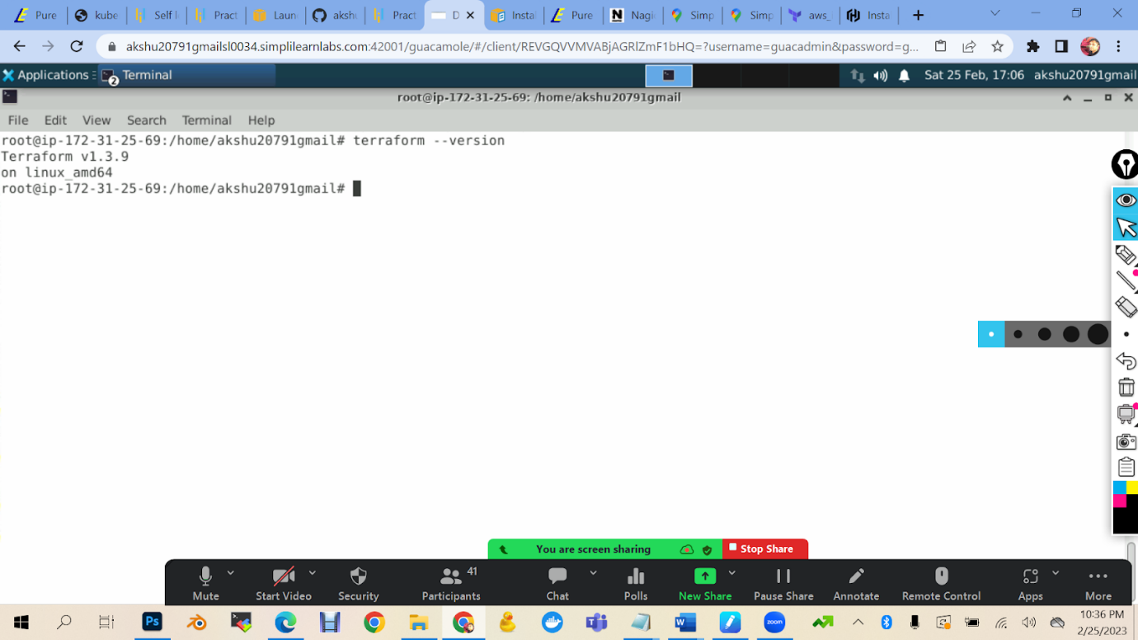

8_) now we will connect our simplilearn machine with aws account

aws configure

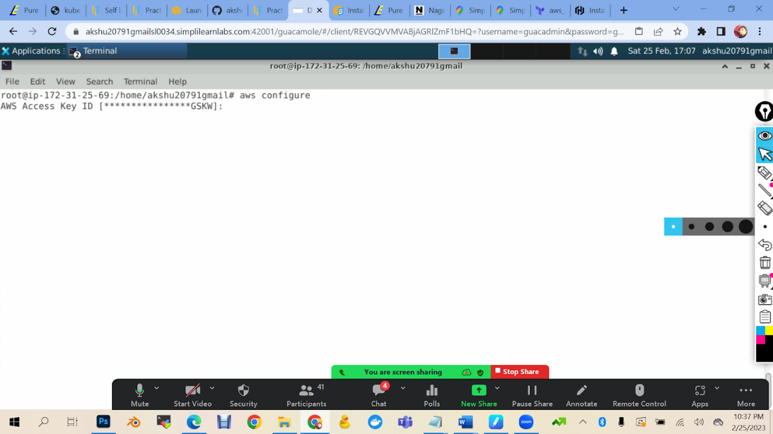

This is asking for authentication

Now I will go to the aws account with which I will connect my simplilearn lab

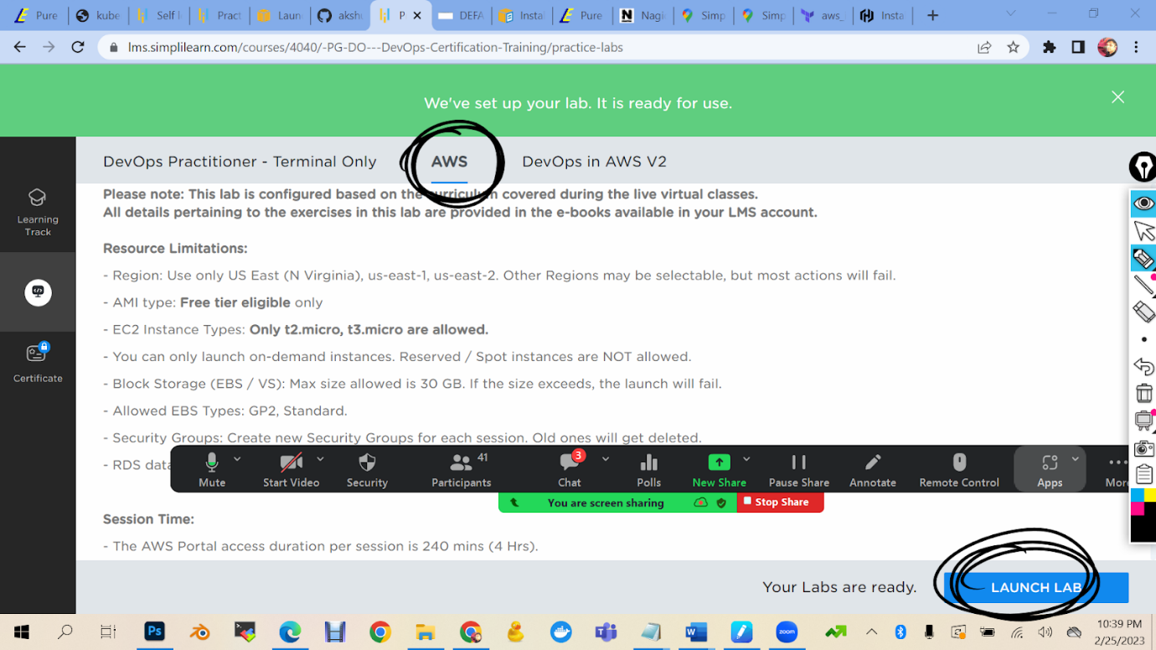

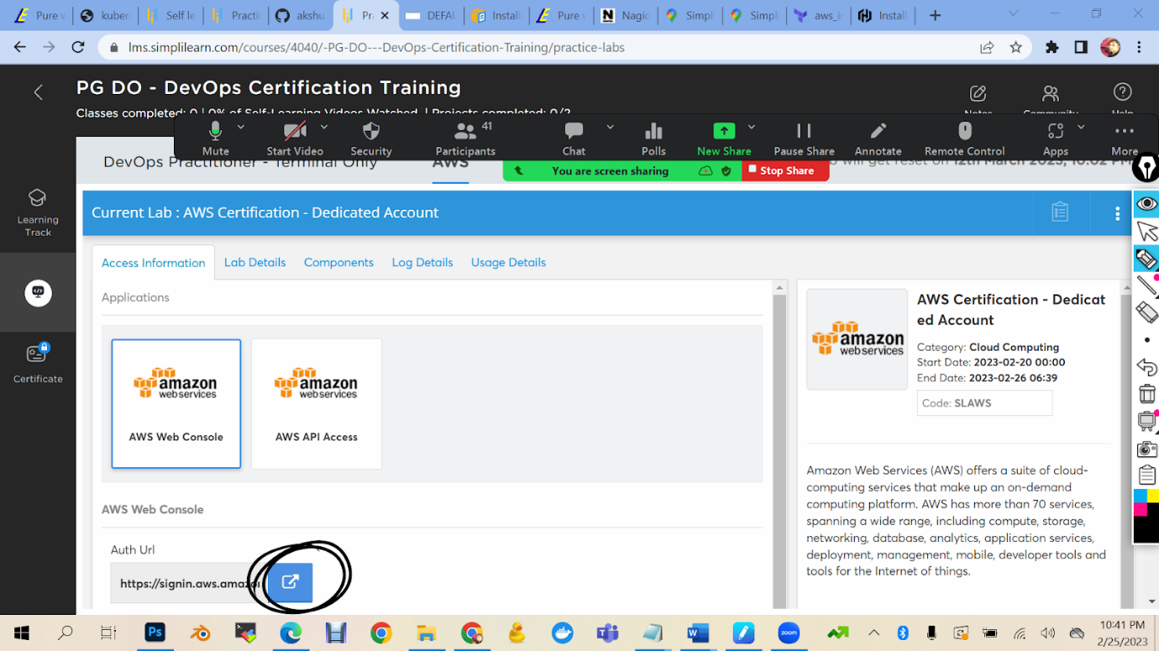

1. 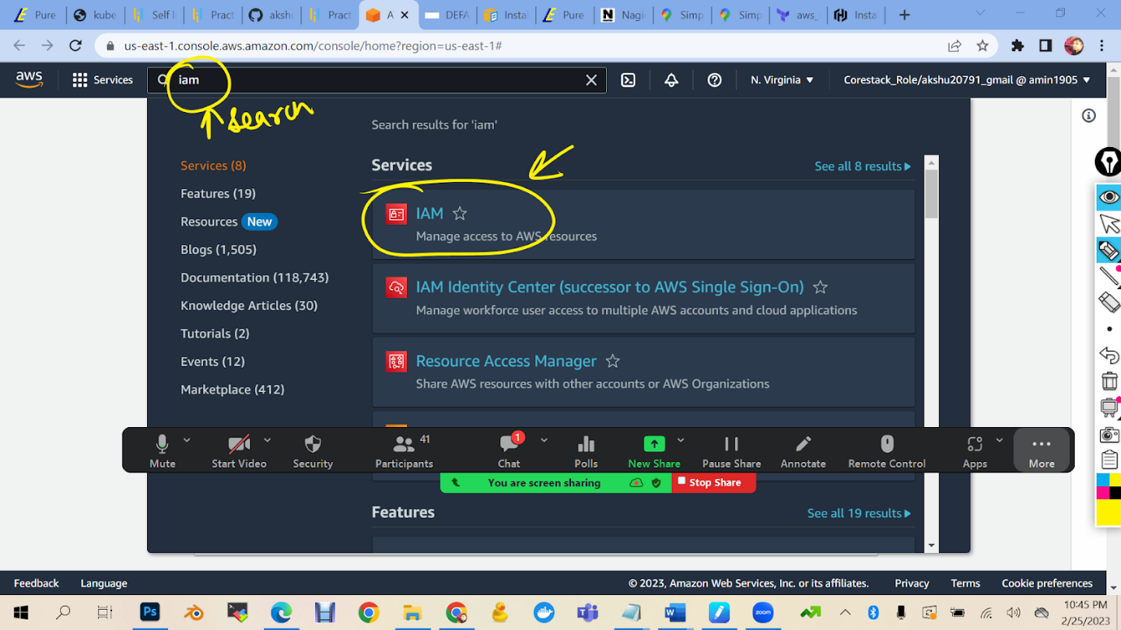

1. 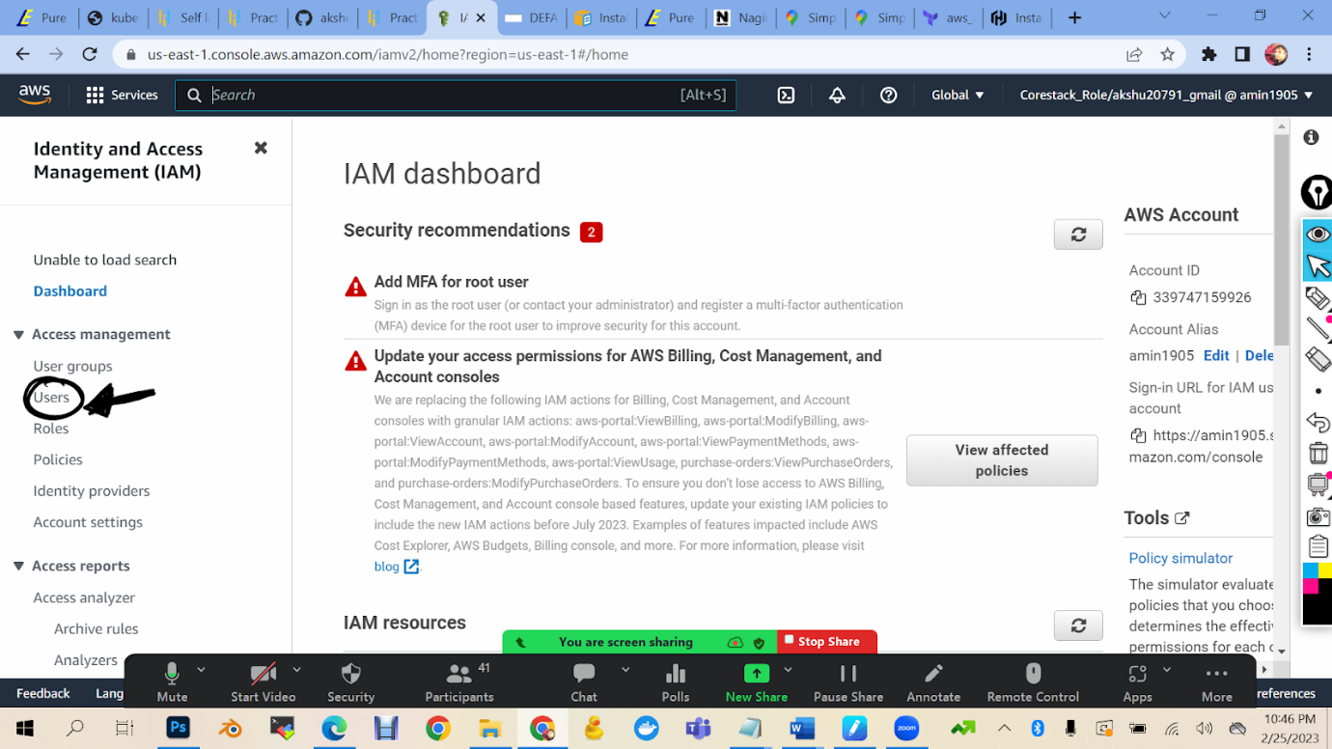

1. 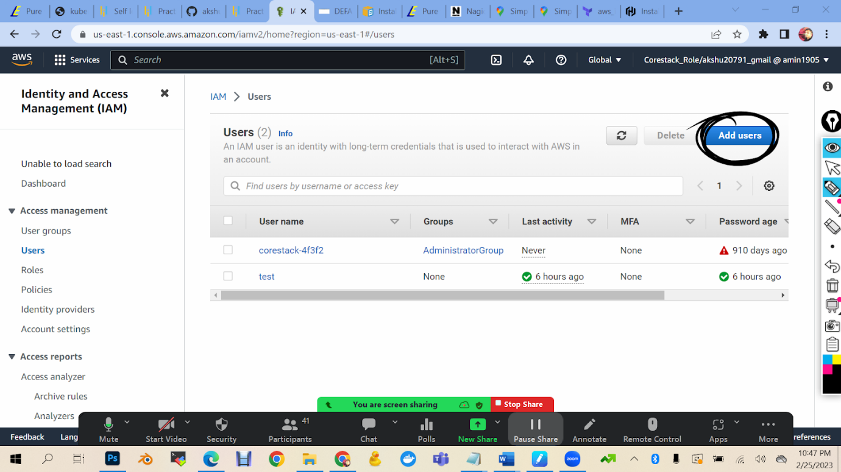

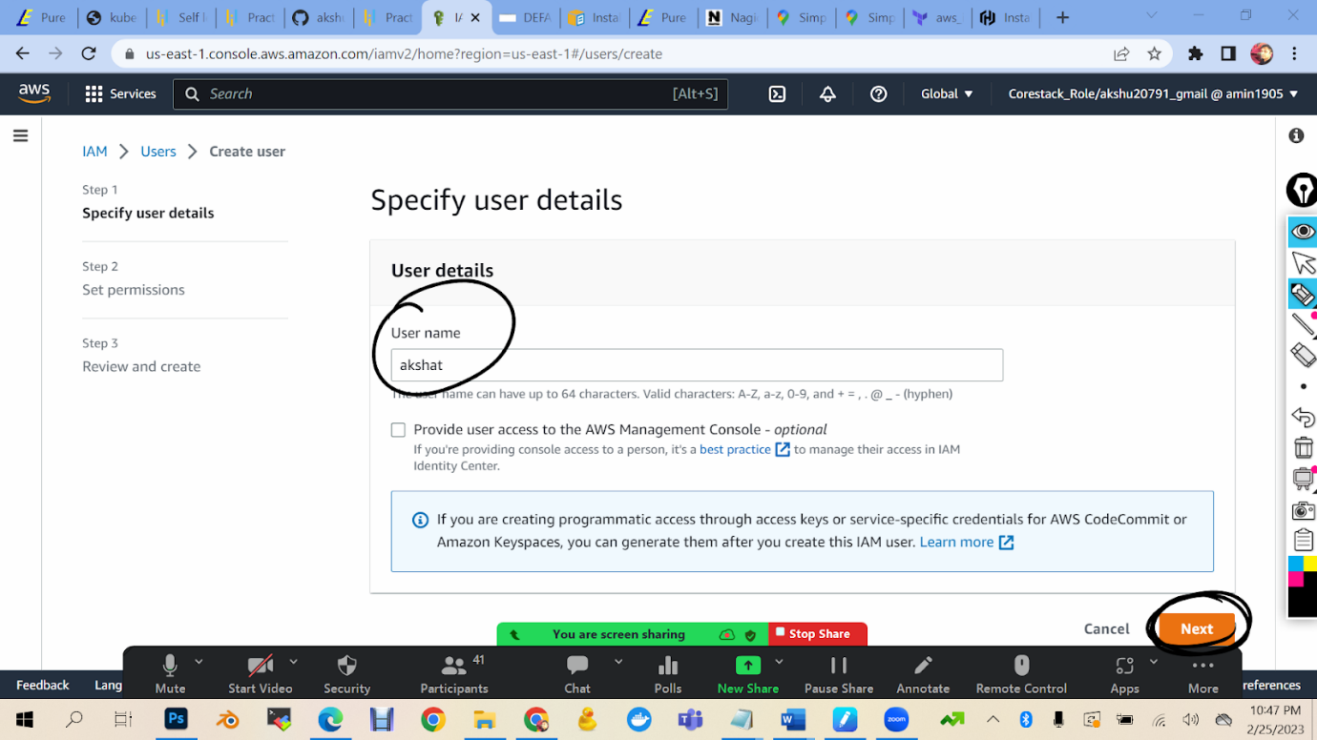

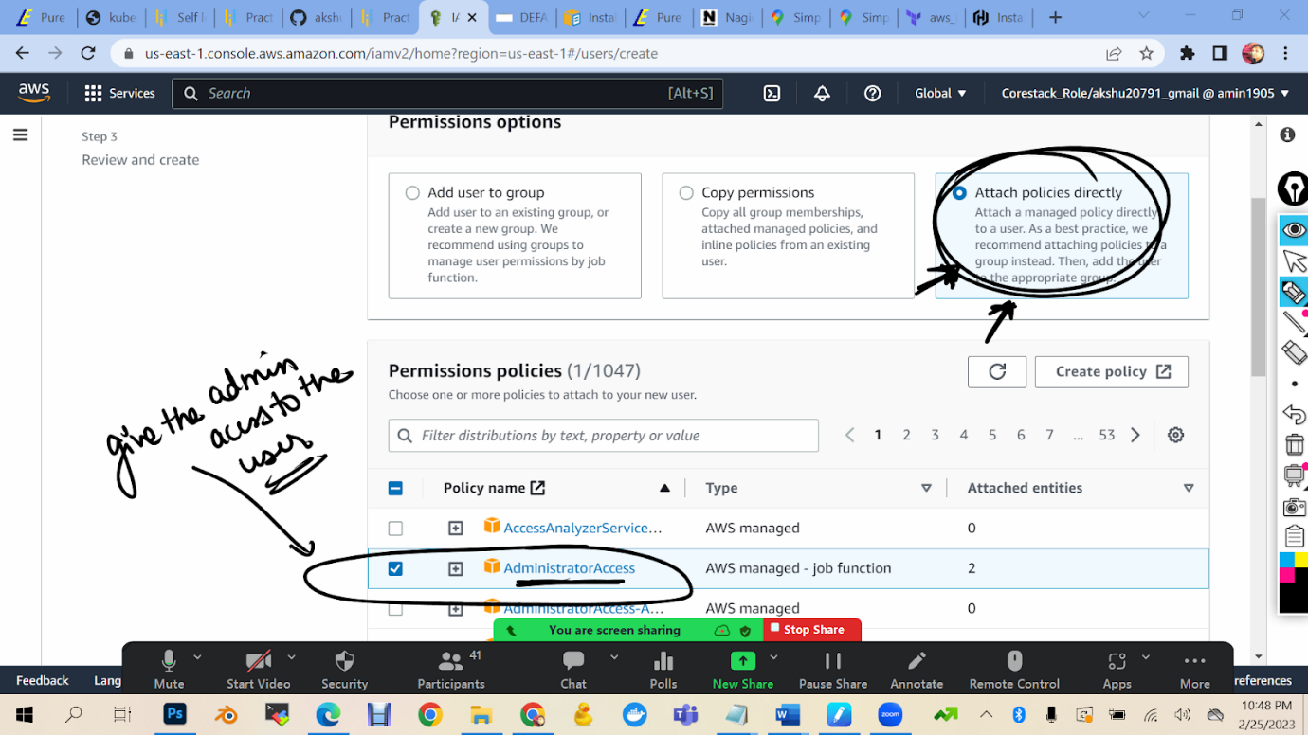

Click on next

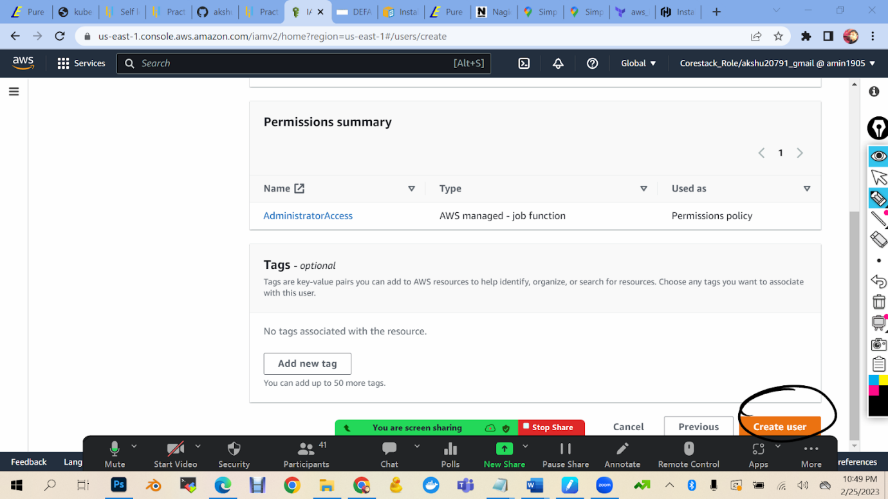

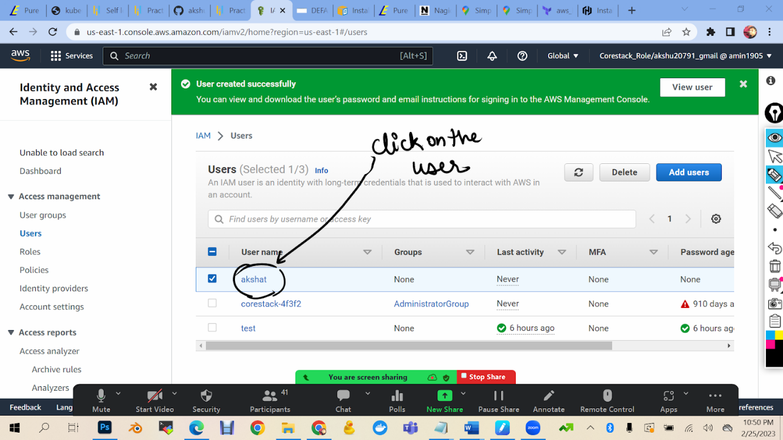

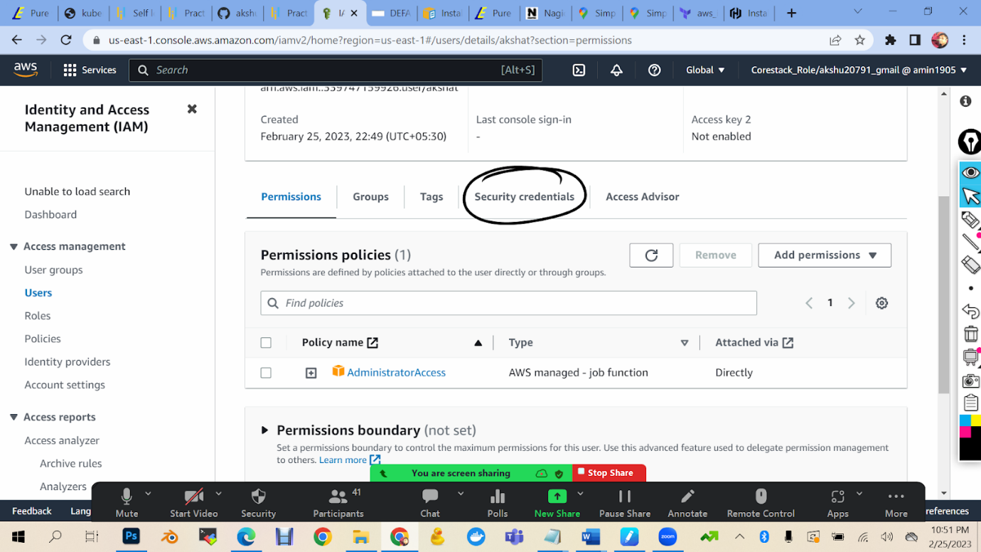

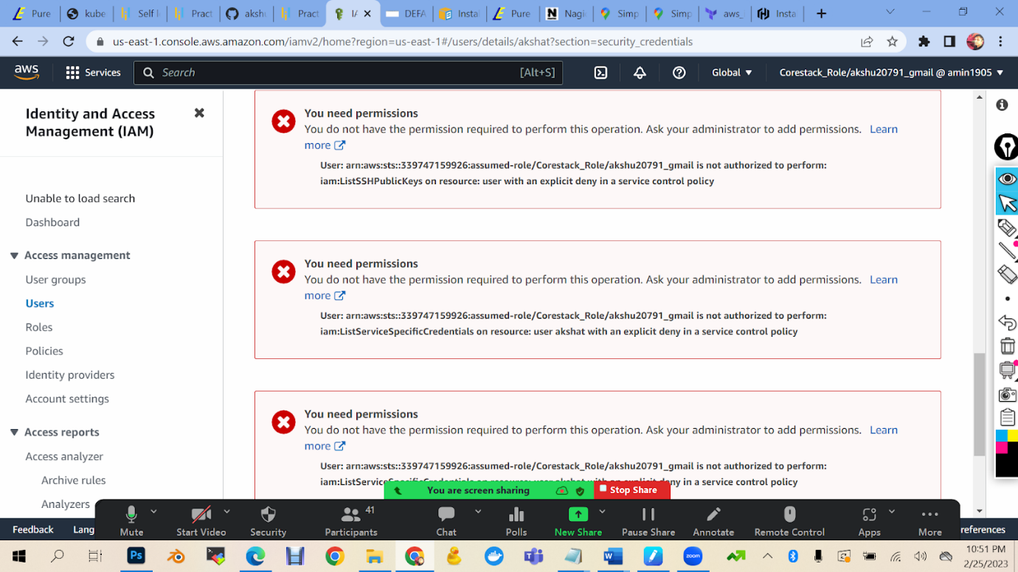

Scroll up

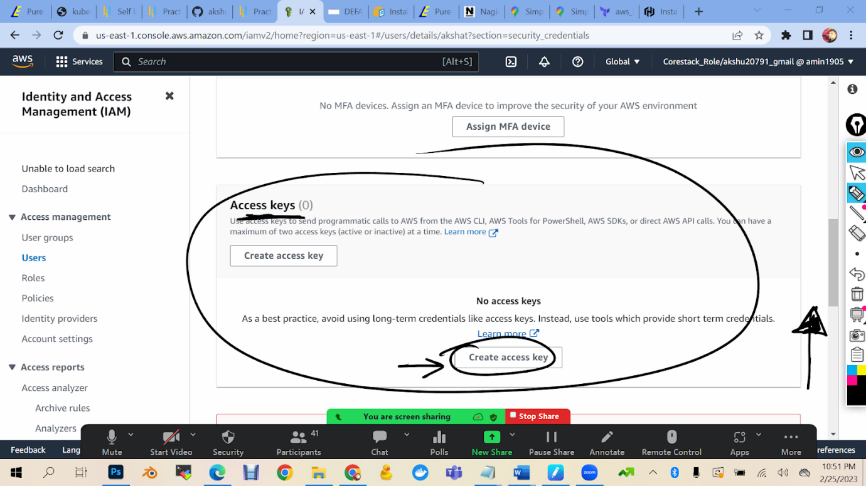

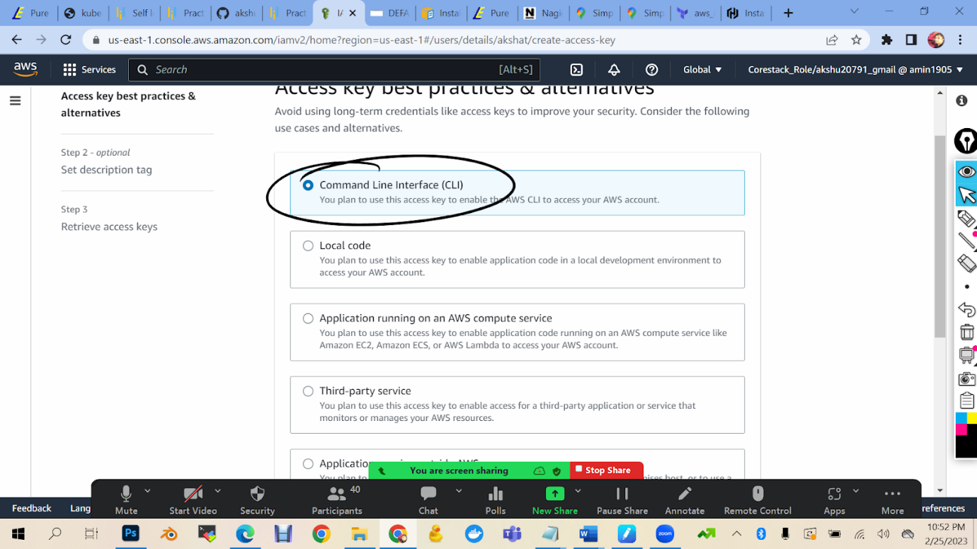

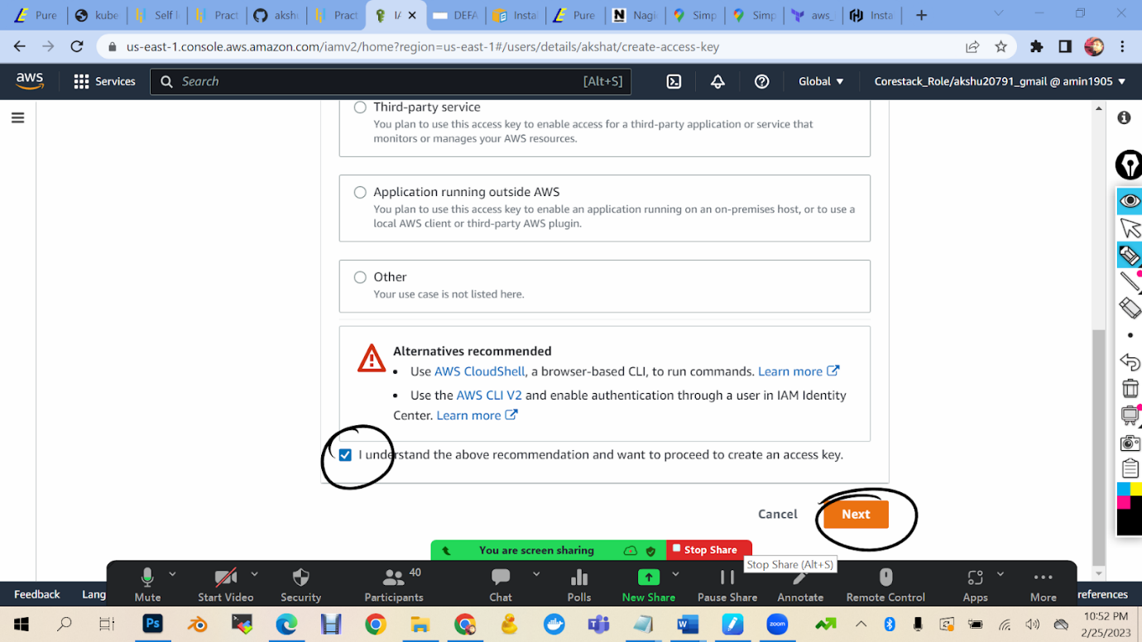

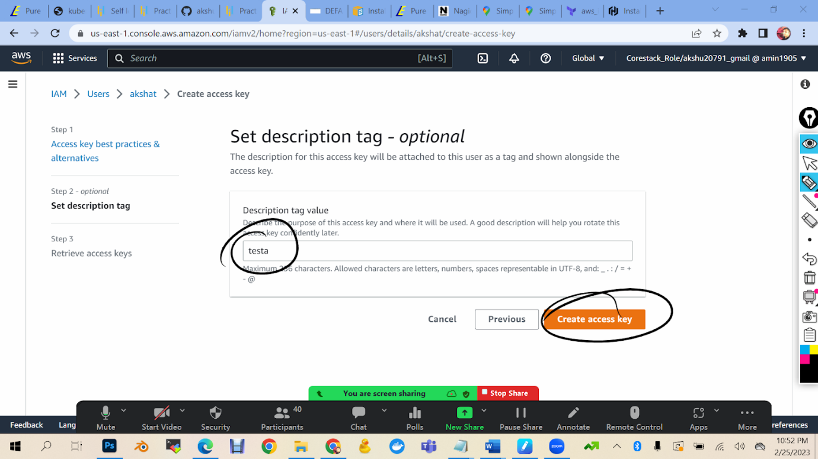

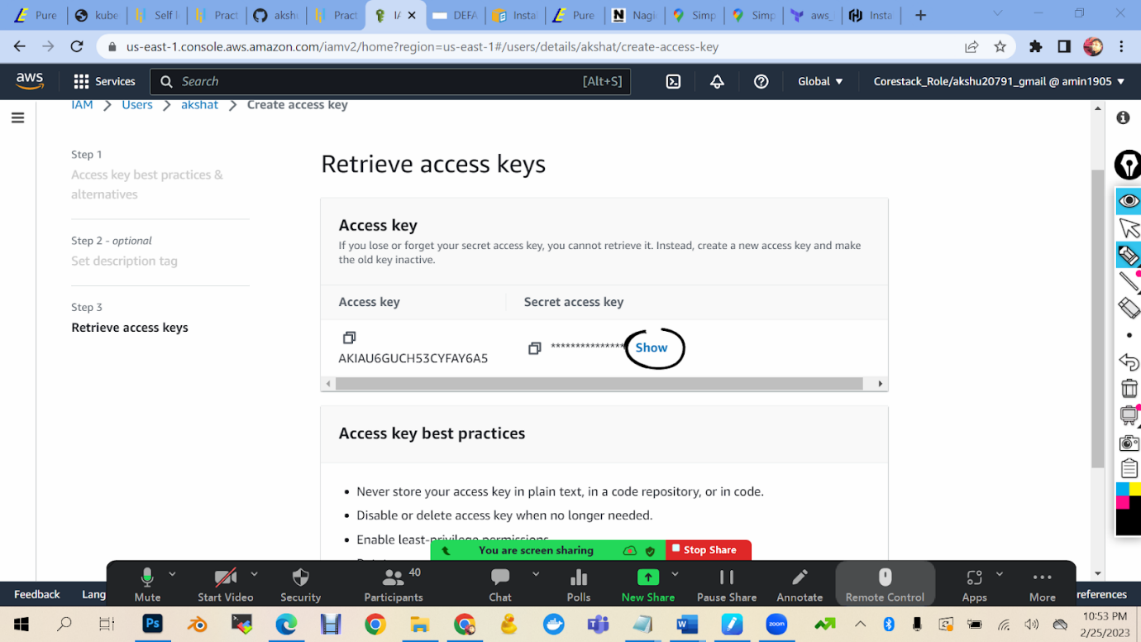

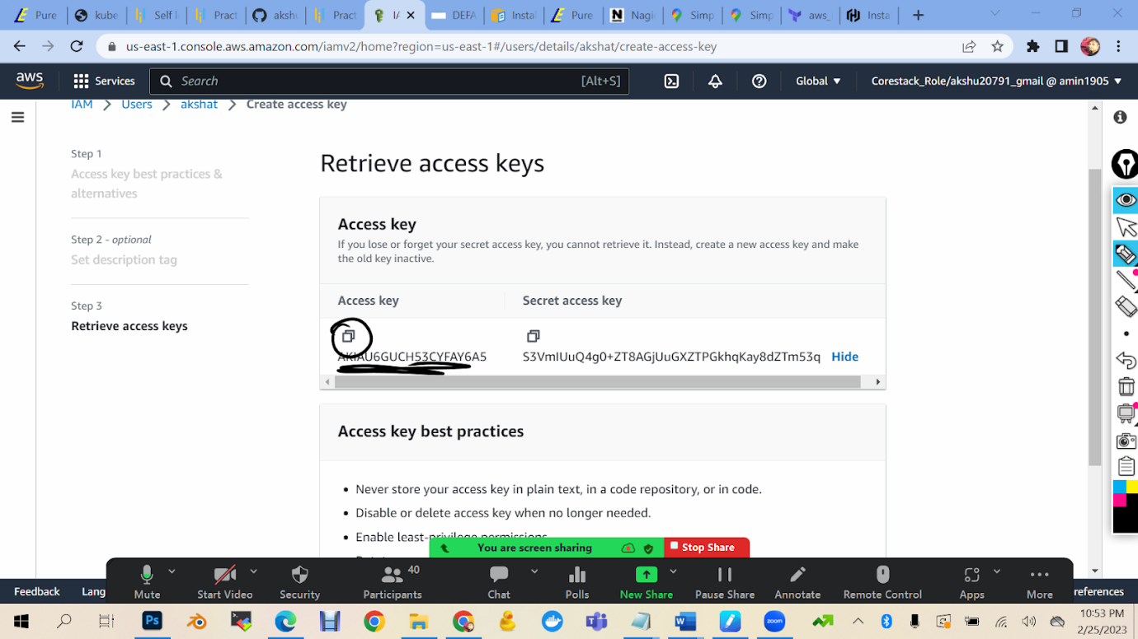

Now we have access key and secret key which we can copy in our simplilearn lab

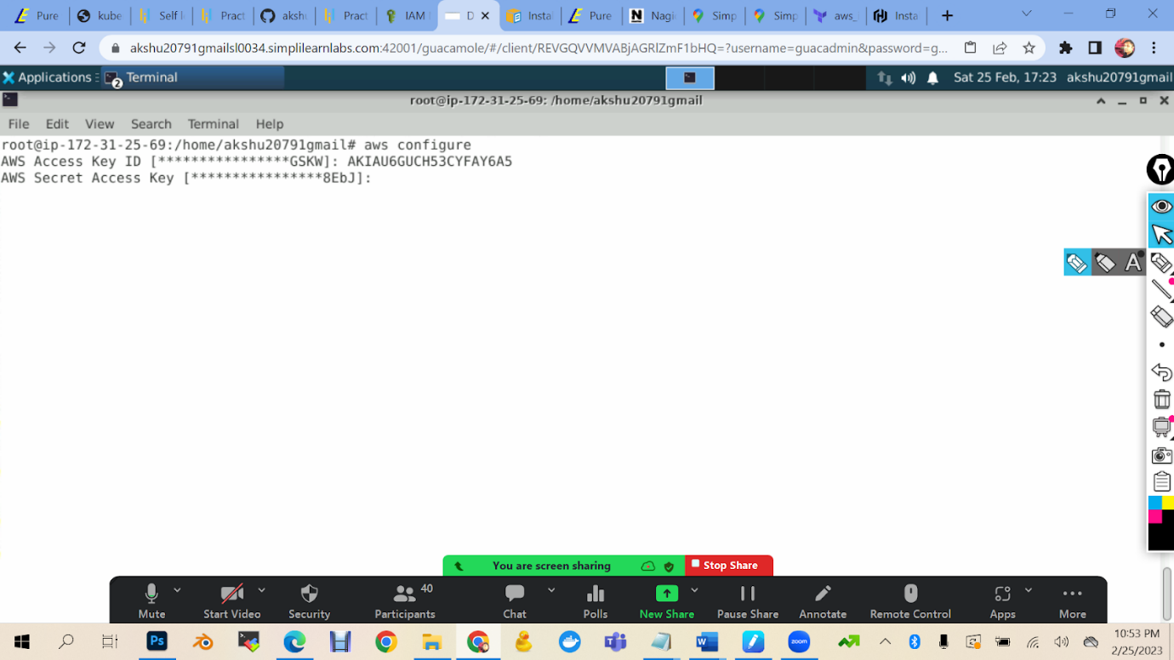

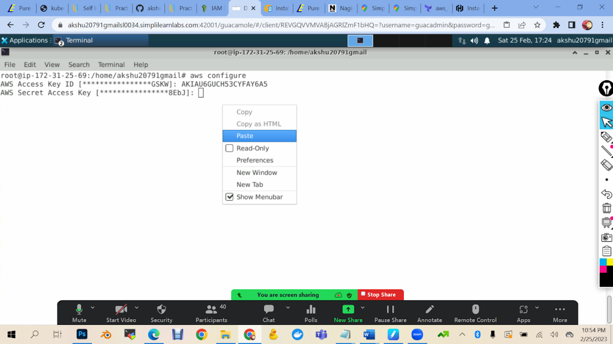

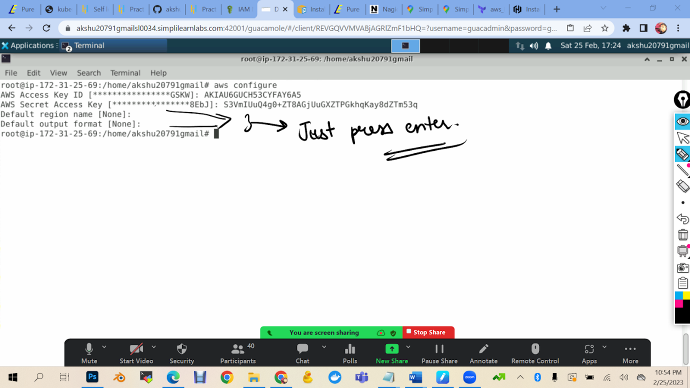

So our first task to write terraform code to create a new ec2 machine

For this we will create a new directory in our simplilearn machine

mkdir projectakshat

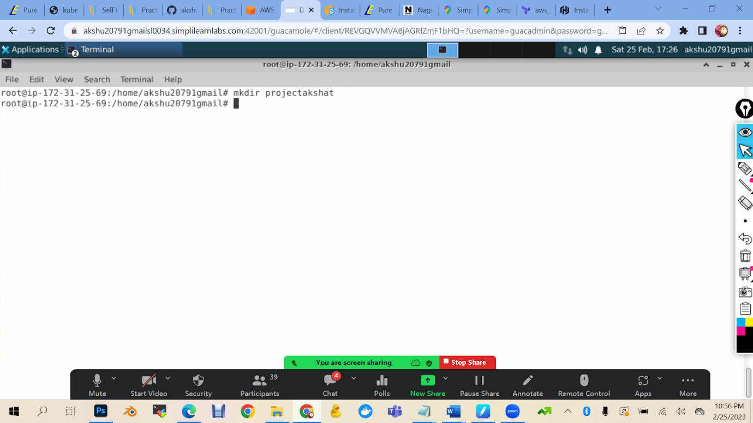

ls

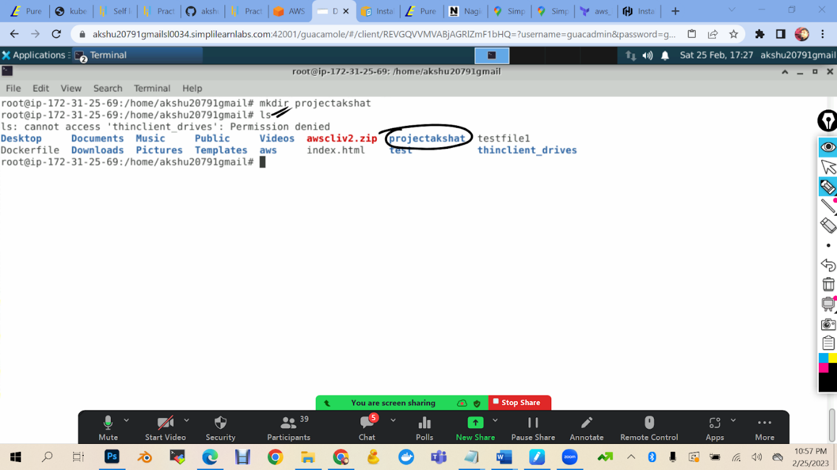

cd projectakshat

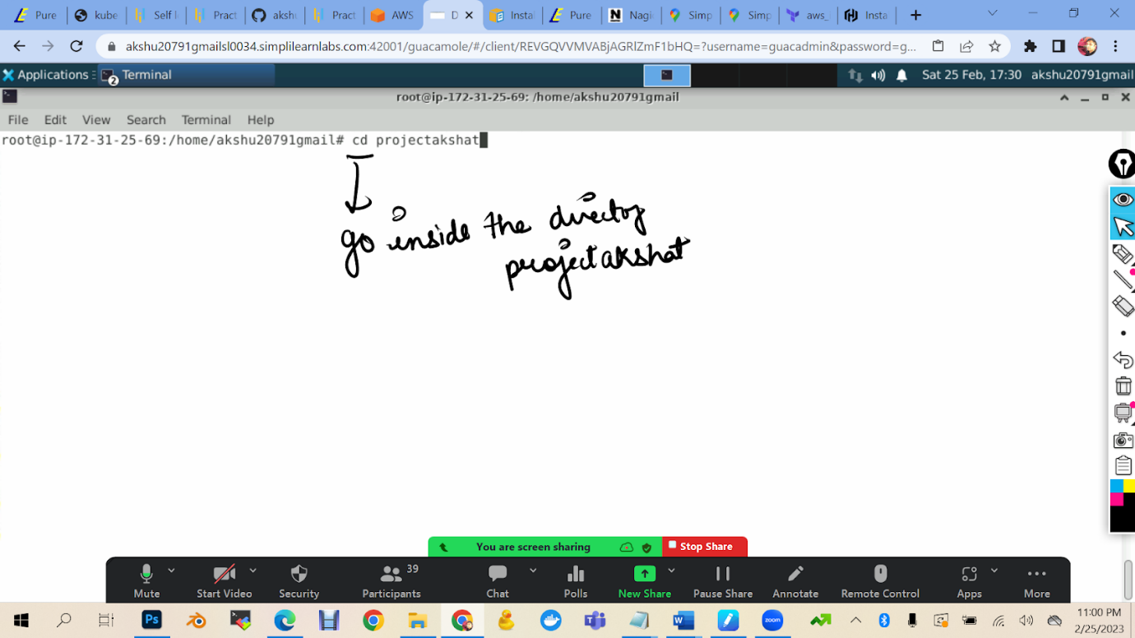

1. Now I will create a file in which I will write the code to create ec2 machine

vi ec2.tf

 (tf full form is terraform file)

Press i

provider "aws" {

  region     = "us-east-1"

}

resource "aws_instance" "foo" {

  ami           = "ami-0dfcb1ef8550277af"

  instance_type = "t2.micro"

}

Press esc :wq

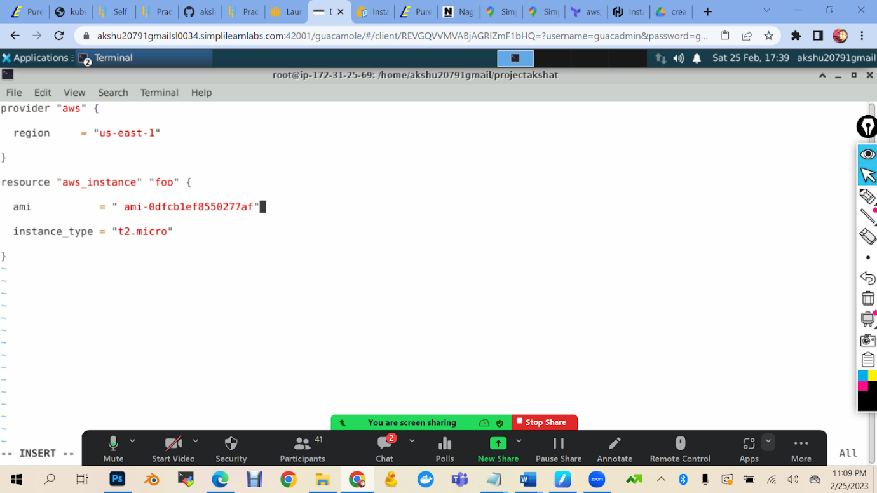

terraform init

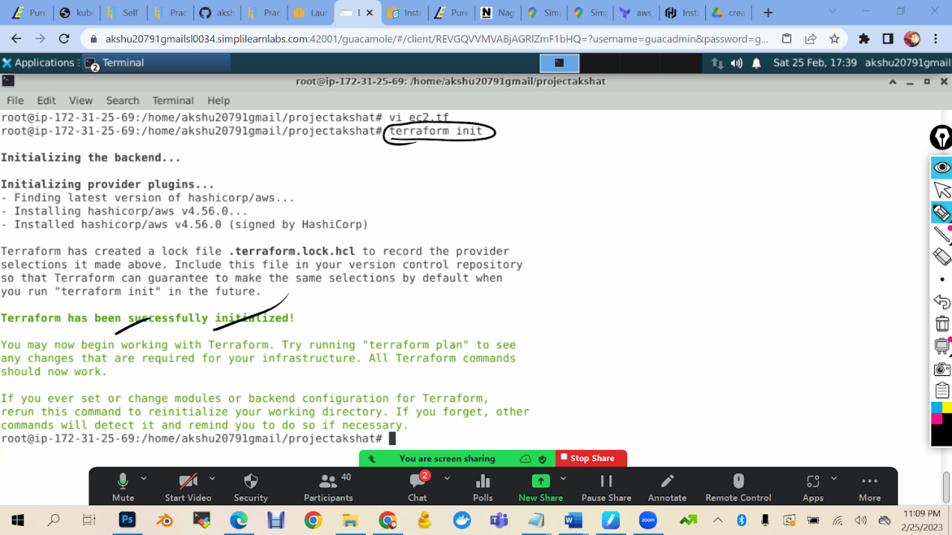

terraform plan

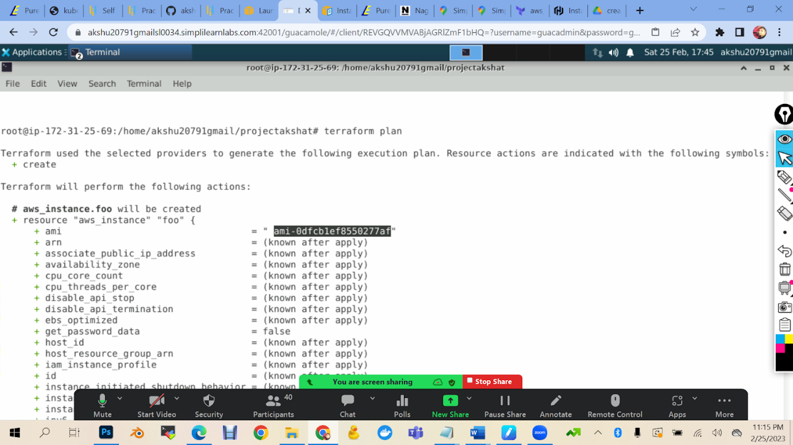

terraform apply

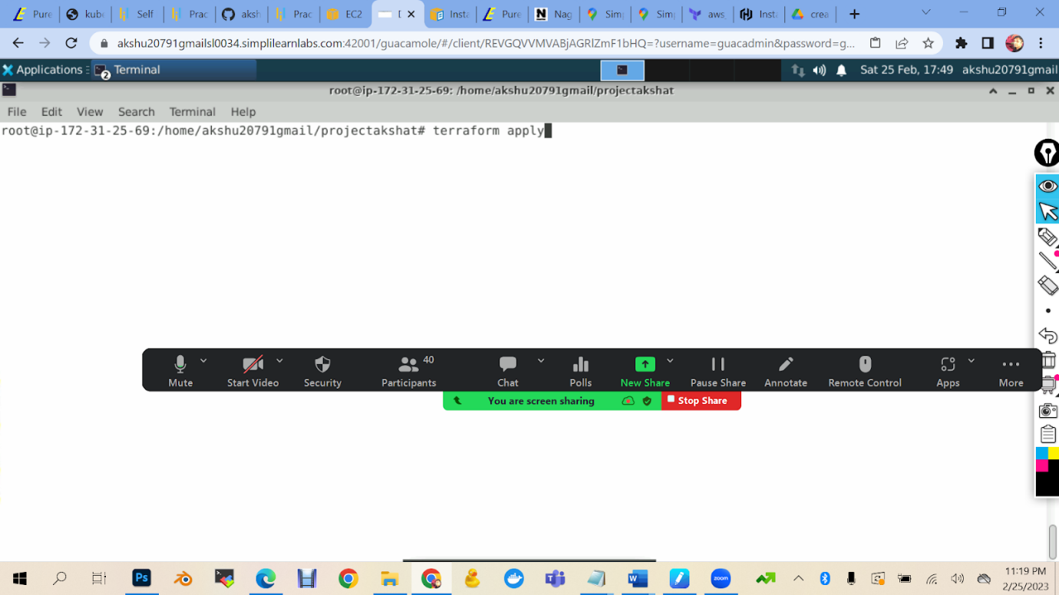

Value to enter : yes

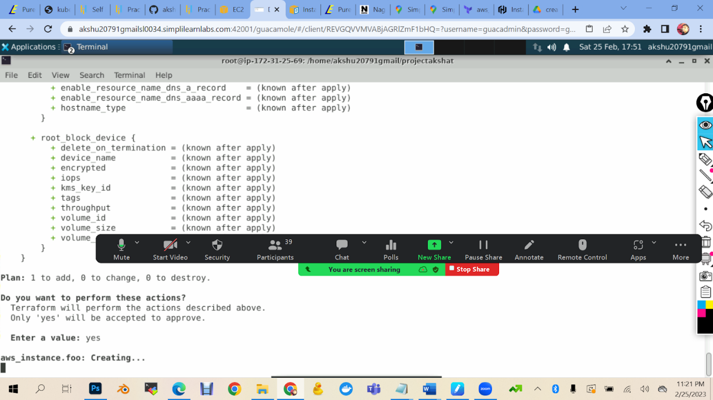

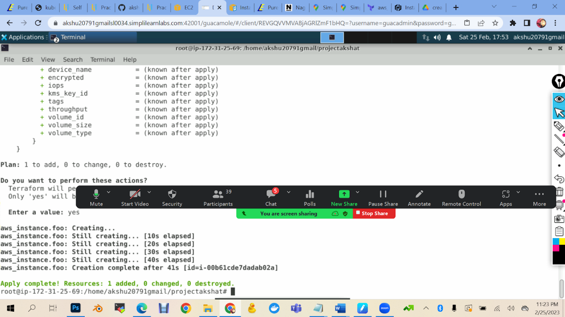

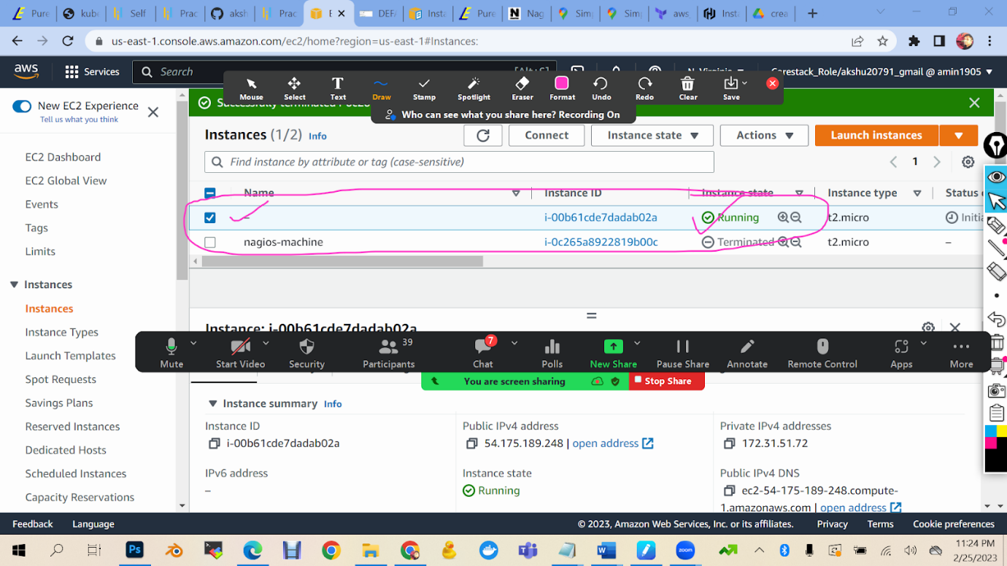

Select yout machine -> security -> select sg….. -> edit inbound rule

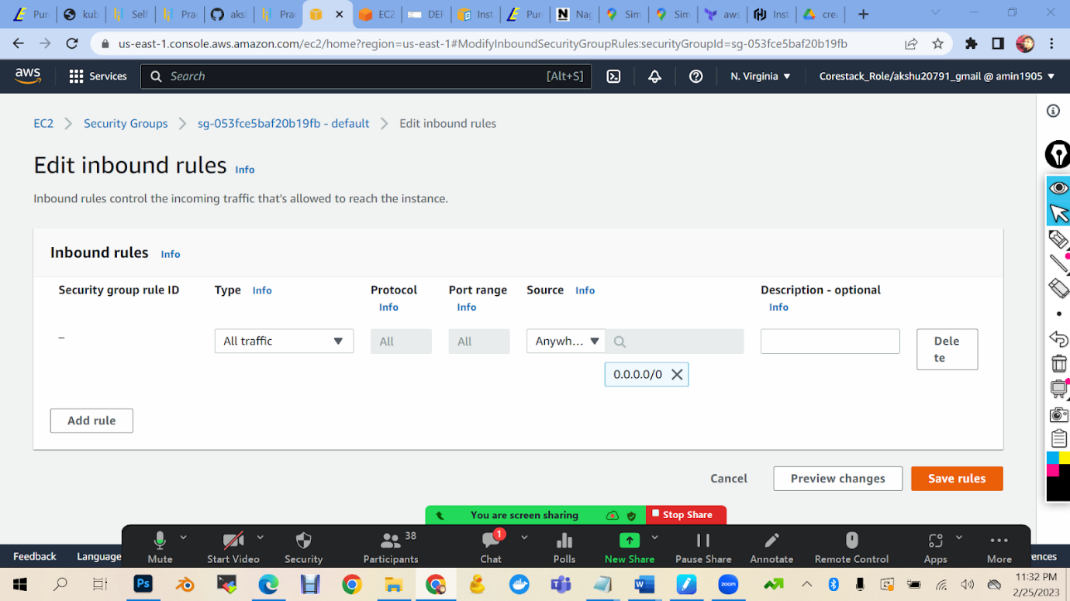

(if you get error delete existing rule and add new rule with type all traffuc and source anywhere ipv4)

Login into the machine

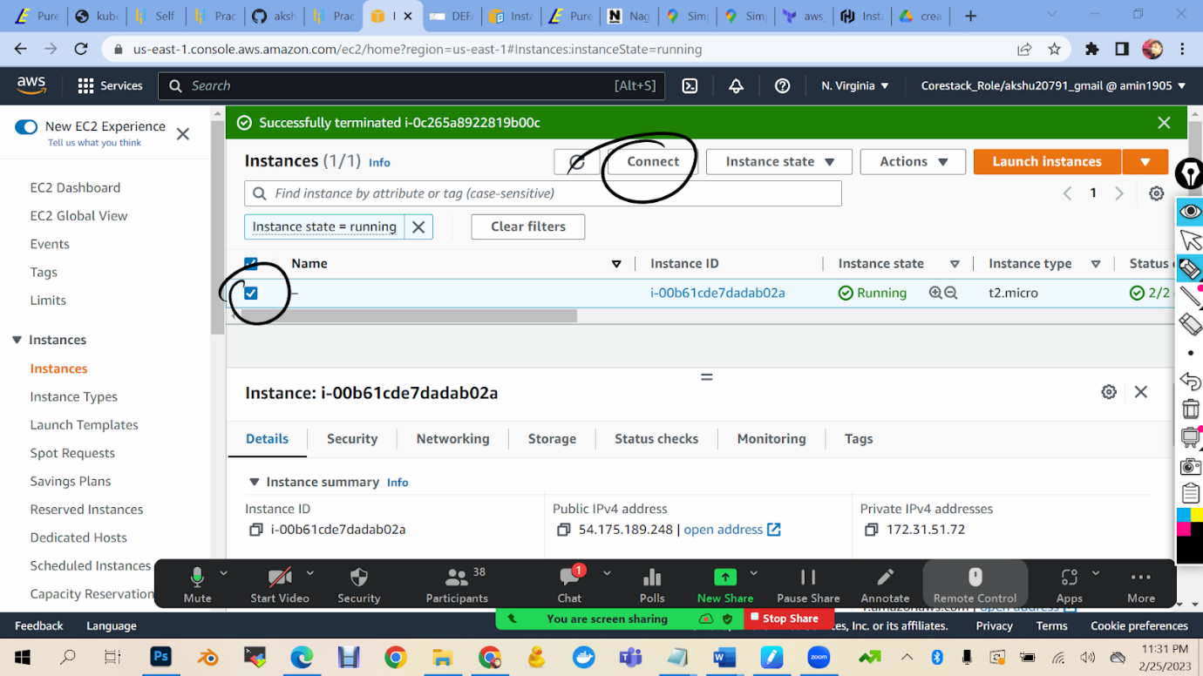

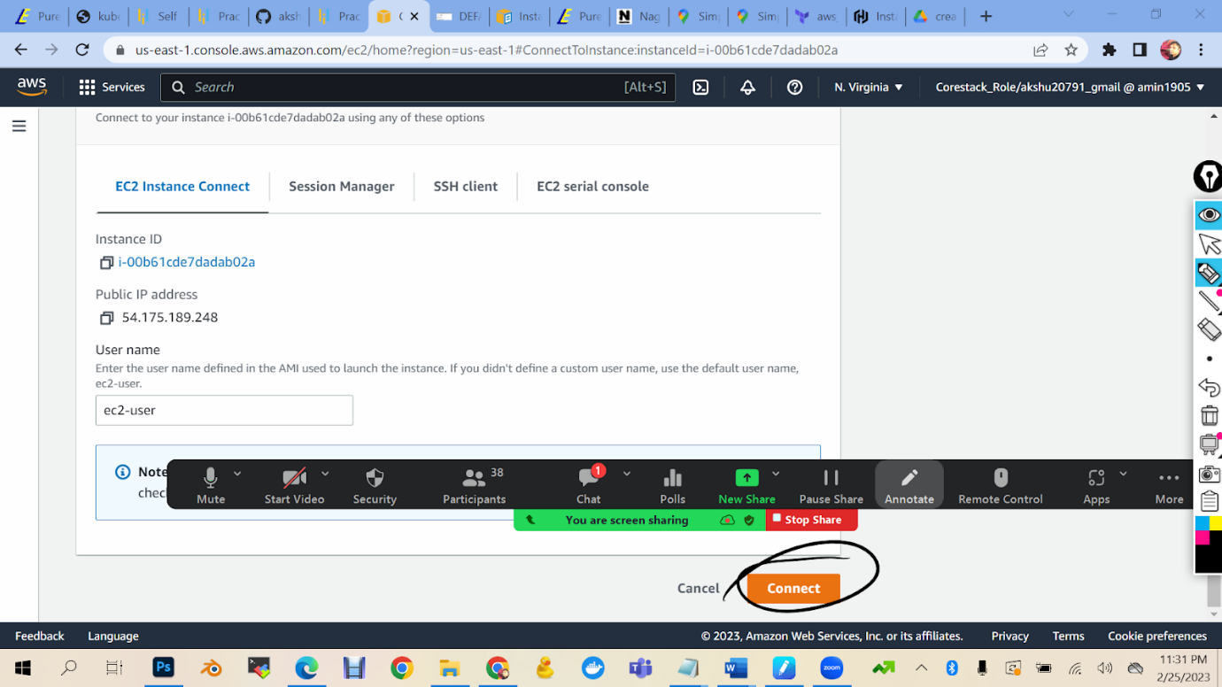

In machine,

sudo su

yum install <https://dl.fedoraproject.org/pub/epel/epel-release-latest-7.noarch.rpm>

yum install python -y

python –version

sudo yum update –y

sudo wget -O /etc/yum.repos.d/jenkins.repo \    https://pkg.jenkins.io/redhat-stable/jenkins.repo

sudo rpm --import https://pkg.jenkins.io/redhat-stable/jenkins.io.key

        sudo yum upgrade

sudo amazon-linux-extras install java-openjdk11 -y        (java  installation)

sudo yum install jenkins -y

sudo systemctl enable jenkins

sudo systemctl start jenkins

sudo systemctl status jenkins